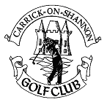
Carrick on Shannon Golf Club
Woodbrook,
Carrick on Shannon,
Co. Roscommon
‘Phone/fax 071 9667015
E-mail: membership@carrickgolf.ie
Web address www.carrickgolf.ie

PRESS RELEASE

Happy Christmas and New Year.
The officers and Parent Committee of the Golf club would like to wish all members and their families a very happy Christmas and good new year. We would like also to wish all our very generous sponsors a very happy Christmas, and ask all our members to support our sponsors.

